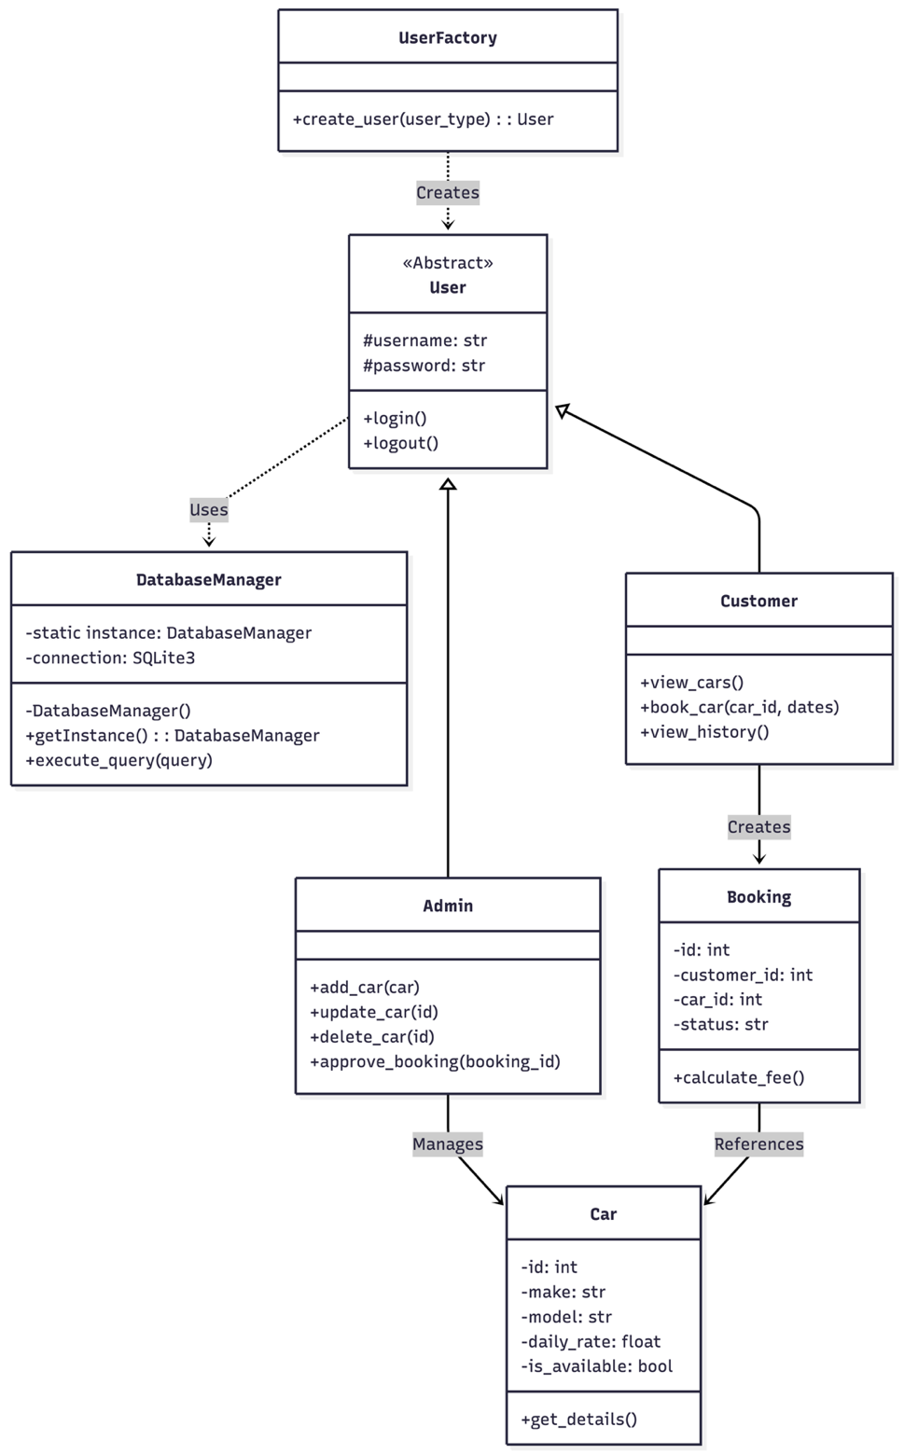
The Class Diagram demonstrates Inheritance where Admin and Customer derive from the abstract User class. Encapsulation is strictly followed by keeping attributes private (denoted by -). The DatabaseManager implements the Singleton pattern to centralize data access.

